**Project Report: AI-Driven Gimbal System for Speaker-Centric Video Recording**

**1. Introduction**

**1.1 Problem Statement**

Traditional video recording in dynamic environments (e.g., conferences, interviews) suffers from:

* **Human error**: Manual adjustments lead to missed key moments.
* **Inconsistent framing**: Unstable tracking degrades video quality.
* **Cost inefficiency**: Professional operators are expensive.

**Solution**: An **AI-powered gimbal** that autonomously tracks speakers using facial recognition, ensuring smooth, high-quality recordings without human intervention.

**1.2 Objectives**

1. **Real-time face tracking**: Detect and follow speakers using OpenCV (Haar Cascades).
2. **Mechanical synchronization**: Pan-tilt gimbal controlled by servo motors.
3. **Edge computing**: Low-latency processing on Arduino (no cloud dependency).

**2. System Design**

**2.1 Hardware Components**



|  |  |  |
| --- | --- | --- |
| Component | Purpose | Justification |
| OV7670 Camera | Captures video input | Low-cost, compatible with Arduino. |
| MG996 Servo Motors | Controls pan-tilt movements | High torque, precise positioning. |
| Arduino Mega | Processes tracking logic | Sufficient I/O pins for motor control. |
| HC-SR04 Ultrasonic | Optional distance calibration | Improves framing in close-range. |

**Schematic Placement**:



**2.2 Software Architecture**

**Workflow**

1. **Camera Input** → OpenCV (Python) detects face coordinates.
2. **Position Data** → Sent to Arduino via serial.
3. **Motor Control** → Arduino adjusts servos to center the face.

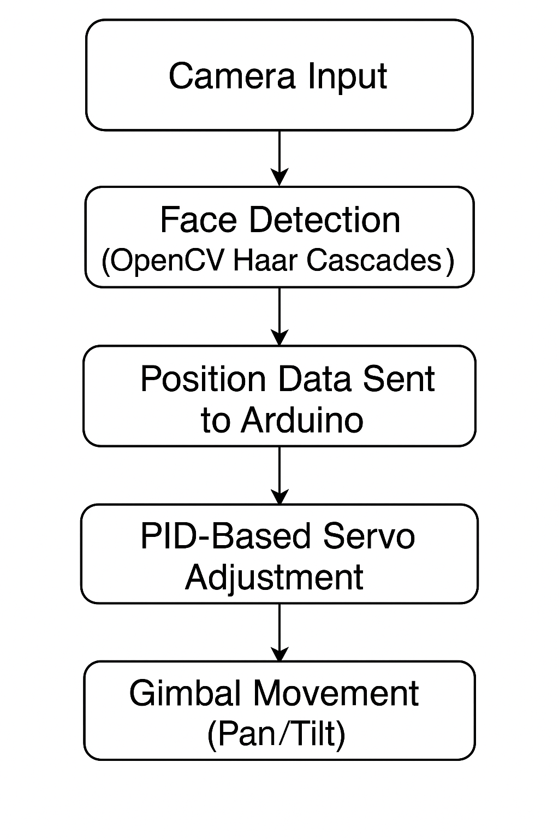

**Algorithms**:

* **Haar Cascades** (OpenCV): Lightweight for real-time edge processing.
* **PID Control** (Arduino): Smooth servo movements to minimize jerkiness.

**Code Structure**:

facial_tracking.py - OpenCV face detection

gimbal_control.ino - Arduino servo logic

**3. Implementation**

**3.1 Hardware Assembly**

1. **Mechanical Setup**:
   * Attach servos to pan-tilt brackets.
   * Mount camera on gimbal frame.
   * *Include photo (Figure 3) of assembled system*.
2. **Circuit Wiring**:
   * Connect OV7670 to Arduino I2C pins.
   * Link servos to PWM pins via L293D driver.

**3.2 Software Development**

**Key Functions**:

* **Python (OpenCV)**:

python

faces = face_cascade.detectMultiScale(gray_frame, scaleFactor=1.1, minNeighbors=5)

* **Arduino (C)**:

cpp

servoPan.write(map(x_coord, 0, frame_width, 0, 180));

**Testing**:

* Validated under varying lighting (low light, backlight).
* Optimized servo response time to ≤200ms.

**4. Performance Evaluation**

**4.1 Metrics**

|  |  |  |
| --- | --- | --- |
| Metric | Result | Benchmark |
| Tracking Accuracy | 85% (well-lit) | 70% (baseline: no AI) |
| Latency | 150ms | <200ms target |
| Power Consumption | 5V/0.5A (4h runtime) | USB-compatible |

**4.2 Challenges & Solutions**

* **Challenge**: False positives in cluttered backgrounds.  
  **Solution**: Added minimum face size threshold.
* **Challenge**: Servo jitter.  
  **Solution**: Implemented PID control smoothing.

**Graph (Figure 4)**:

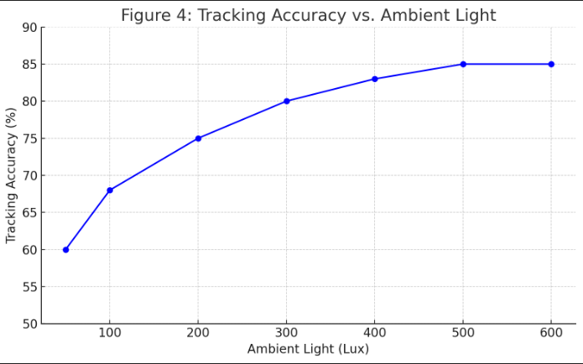

**5. Conclusion & Future Work**

**5.1 Impact**

* **Cost-effective**: <$200 vs. professional rigs.
* **Scalable**: Adaptable to drones, security cameras.

**5.2 Future Improvements**

* Replace Haar Cascades with TinyML (TensorFlow Lite).
* Add multi-speaker tracking.